**Exp. 4 Cloud Software Application**

**Aim:**

Create a simple cloud software application for Car Booking Reservation System using any Cloud Service Provider to demonstrate SaaS.

**Procedure:**

* Open Zoho Website and Login with your Zoho Account
* Select the Creator app and click on Create Application in the top right.
* Create the application from scratch with an appropriate name.
* Click on “create new form”. If required, choose a template from the available ones. If not, then create your own template.
* Click on “access this application” in the top, then enter data into the form, check if the data is stored properly after entering and saving the forms

**Output:**

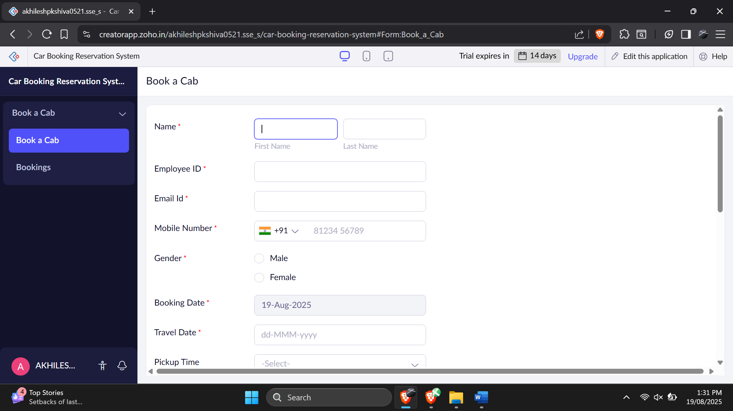

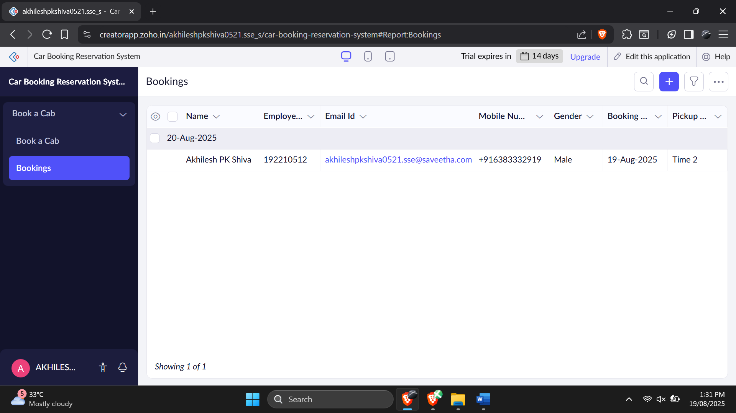

**Result:**

Thus the application for flight reservation system was created successfully